Information Card for:
Educational Robotics
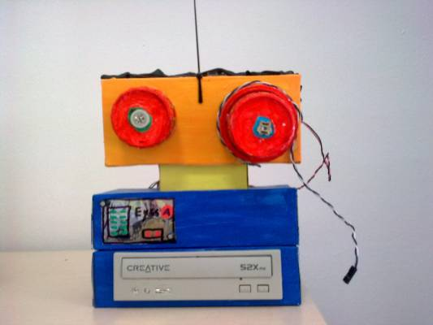
Context:
In the Gaslini Children’s Hospital in Genova, Italy, the principles of 'Educational Robotics' is used in a hospital context. In this case, a team of teachers and experts from the Robotics School of the CNR (Italian National Research Centre) taught students with medical needs how to build small robots.
This methodology has been used since 1996 with various additional developments and techniques. In the beginning, only simple home-made robots where created, often using materials that could be found in the hospital. Later, the Hospital and the Robotics School formalised an agreement with LEGO (kit Education WeDo - http://education.lego.com/it-it/preschool-and-school/lower-primary/7plus-education-wedo) to be able to use their materials in the wards.
Homepage (Italian only):
http://pso.istruzione.it/index.php/robot-realizzati-dai-bambini-in-ospedale

Possible uses in a Home and Hospital Education (HHE) context
Educational Robotics (ER) can be used in multiple ways within a hospital school or in home tuition, however, you will need experienced professionals/researchers or practitioners to use it effectively in any context.
The results can be exceptional, to the point where ER is used in rehabilitation-specific areas (for example, in visual impairment), both to promote the learning curriculum, but also to expand on it, as it includes other subjects such as logic, mathematics, science and technology etc. This constructive/constructionist methodological approach has allowed the children to learn how to play with- and even design and build their own toys.
Creating robots has motivated the children to approach study in a very appealing way, which is not common in an area that is heavily institutionalized, such as that of a Hospital School, where teaching must carefully follow the institutional guidelines.
There is a video (which is in Italian) that can be accessed via the link below, which contains some examples:
https://www.youtube.com/watch?v=RcRnfokQyxg
There is also an interview with Immacolata Nappi, the teacher responsible for introducing ER in the Gaslini Hospital (which has been involved in the LeHo focus groups):
http://new.livestream.com/triwu/events/3060779
...however, this is also in Italian. Below is the link to a summary of the work, but this is also in Italian. A free, online translation service (http://www.freetranslation.com/) will provide you with some idea of the contents.
http://pso.istruzione.it/images/easyblog_images/71/Gaslini-Genova---Robotica-con-i-bambini-ospedalizzati_20140917-130914_1.pdf

Notes:
This activity is not expensive if you want to do it with basic resources, but it can cost more be if you want to use Lego and software to control the robots.
The main issue here is competence, as it is not so easy to find people experienced in robotics and moreover, educational robotics.

What do teachers need to carry out the activity?
- Someone with some experience in robotics and educational robotics.
- Access to the internet.
- Identify a context (with one or more children with medical conditions) where you wish to try this practice.
- Try to become familiar with the basic concepts, starting from scratch:
https://en.wikipedia.org/wiki/Educational_robotics
- Look for online tutorials to be able to use this activity and pass it on to other teachers.
- Identified students that may suit this kind of interaction.
- Gather the materials (in more advanced cases also software and hardware, but mostly just the basic stuff needed to create the robots).
- Evaluated the process and impact on pupils, and provide feedback following the trail of this activity via Survey Monkey (see the last page for links).
Timescales
It would take at least two months for teachers to familiarise themselves with Educational Robotics and also to test it in a real HHE context.
Additional Notes
Teachers may choose to share any films they make during their project on the LeHo YouTube channel: (https://www.youtube.com/channel/UCMD5zSd3x4VqoBwDUVK7n4w).

Educational Robotics
Evaluation of the activity

Evaluation of how this activity worked for you in the field (Fieldwork Experience) is via a short questionnaire on Survey Monkey.
Questionnaires are available in English, Italian, Spanish, Catalan, German and Arabic as follows:
https://www.surveymonkey.com/r/LeHoFieldwork
https://www.surveymonkey.com/r/LeHoItalian
https://www.surveymonkey.com/r/LeHoSpanish
https://www.surveymonkey.com/r/LeHoCatalan
https://www.surveymonkey.com/r/LeHoGerman
https://www.surveymonkey.com/r/LeHoArabic

Please select your language of choice and leave your feedback. Many thanks.

This document is shared under CC-BY 4.0
Edmodo Information Card (2016) by Matteo Uggeri, Politecnico Milano, Italy.

